DWIRE-101 - Classroom
Instructions

Scope
Projector Based Classroom.

- In-Use Light Switch
- Panasonic PT-VMZ50 Projector
- Audio System with Speakers
- Lectern and Rack System
- Document Camera
- Extron Panel
- Crestron Sound Bar

Location
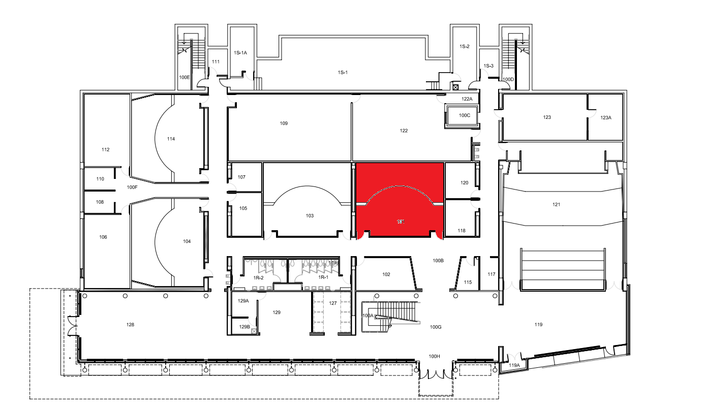
The room can be found in the middle of the Dwire Building’s 1st floor.

Using the System

Turning the system on and off

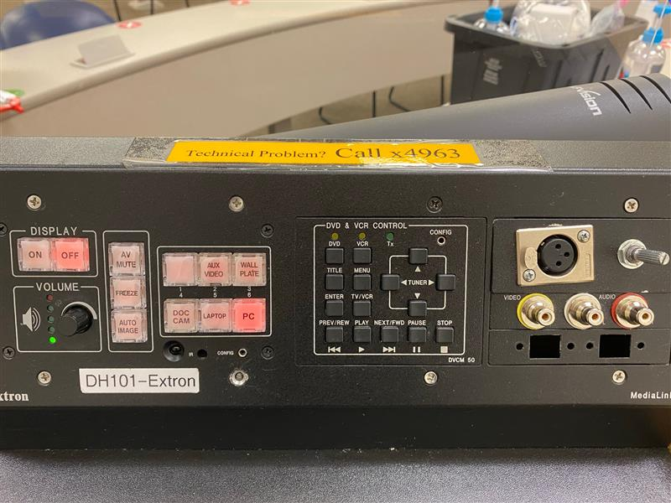

The A/V System is activated with the control panel. Press the On/Off button to turn on display and the screen will come down/up with it.

Source Selection

Press the button with the correct label to switch between the Doc Camera, the Laptop, and the PC. It will default to the last used.

Volume Control

A dial in the bottom left can be turned clockwise for volume up and counter clockwise for volume down. On some occasions, starting up will not play sound unless the volume dial is twisted back and forth.

Projector Control
The projector and screen will automatically power on and off/raise and lower with the system.
To the left of the input selection is three buttons with specific projector controls.
- A/V Mute will shutter the projector and raise the screen. Use this feature when you want to use the whiteboard or front of the room without shutting down the system. Please only use this feature for up to 20 minutes, otherwise it's best to shut down the system.
- Freeze will freeze the currently displayed image on the screen. Use this feature if you'd like to hold a frame still on the screen or use the podium PC for another activity without displaying it, such as checking your email.
- Auto Image will set what the system believes is the best image size for the computer.

Using the Podium PC and Lectern

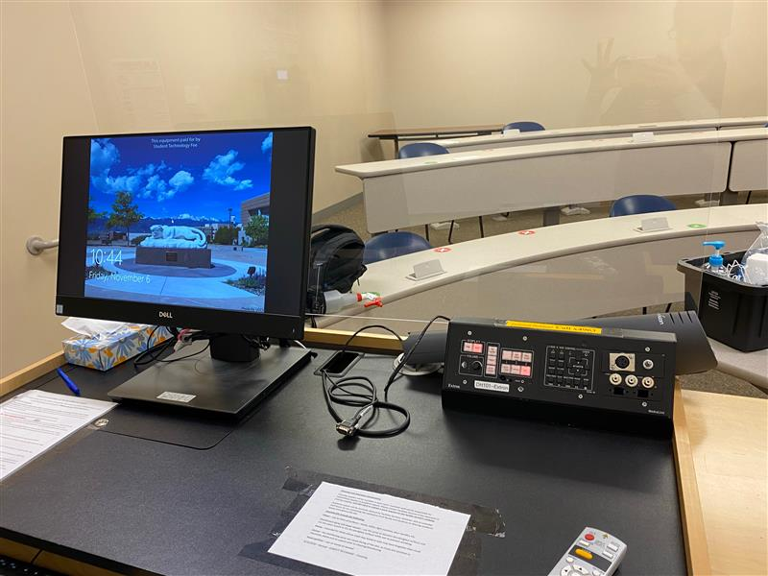

The computer mounted on the podium is the primary source for this AV system. This computer runs the same image as all other podium computers in general fund classrooms and labs. You can sign in with your UCCS credentials.

Using a Laptop

The VGA cable on the lectern is for use with a laptop, with an audio jack to be put in the computer’s headphone port. Connect your device and switch to the laptop input on the panel to project.

Using the Document Camera

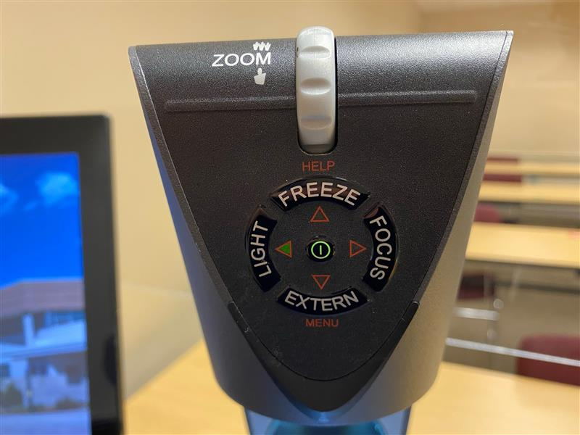
Selecting the document camera source on the panel will route it to the projector. The document camera on the lectern is powered on by holding the power button.
On the top of the camera are controls for zoom and auto focus.

Using the Blu-ray Player

There is no Blu-Ray player. A disk drive can be found on the back right of the computer should a disk need to be played.

Troubleshooting

Audio Issues
Fixing Audio Issues Standard Extron Room

Video Issues
Fixing Video Issues Standard Extron Room

Room Specific Issues

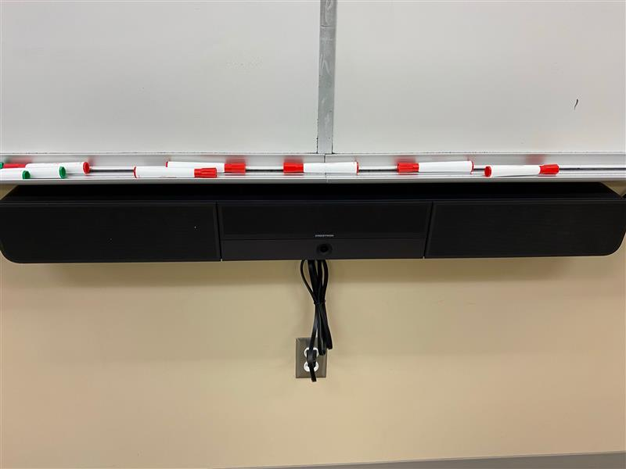
This room has a Crestron Sound Bar. Click here for more information.

Photos
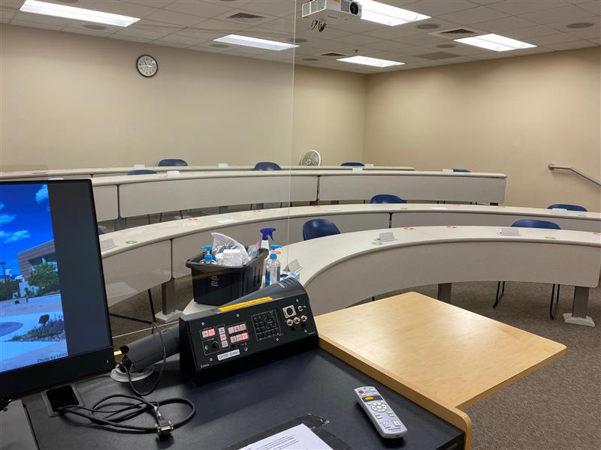
A classroom for lectures
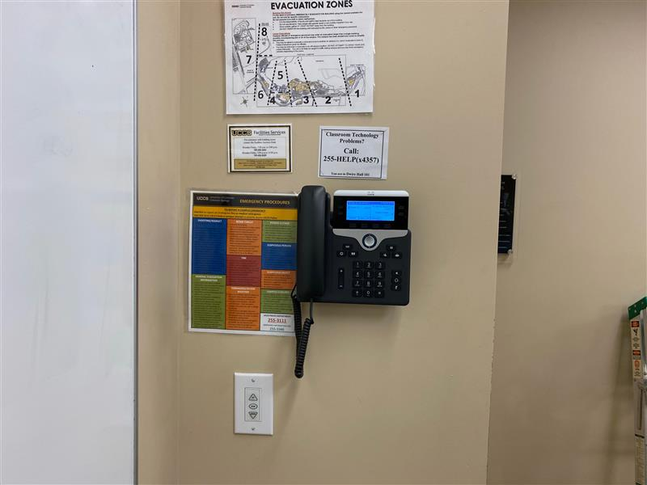
The phone and manual screen switch can be found the left of the podium

